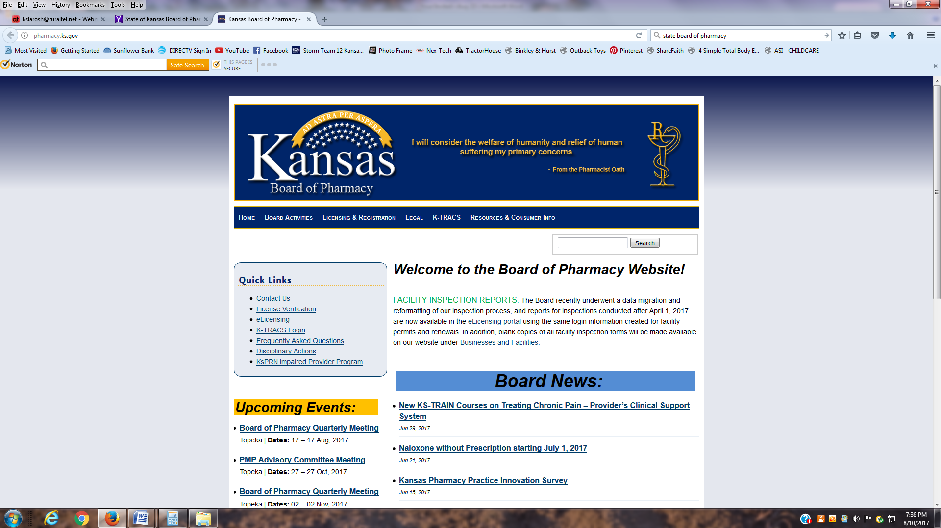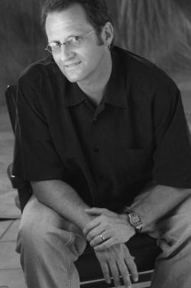

Your are cordially invited to the 5th annual

NURSING CEU TBD

*When it comes to reducing stress in the work place, humor is one of the most effective tools known to business world. Kent Rader believes passionately that laughter matters in easing the daily stress of employees and build a highly cohesive team.*

**REGISTRATION**

Online: http://www.kchponline.com/event-2609341

Fax: 314-845-1891

Mail: KCHP 2650 S. Hanley Rd (St 100) St. Louis MO 63144

*\*Please do not mail after August 18th* May register day of event\**

Facility Name:_______________________________________________________________

Participant Name:_____________________________ Credentials: ______________________

E-Mail Address: ______________________________ Phone Number: (_____) _____-_______

Breakout Sessions Attending: __ A / B / Vendor Fair; C / D / Vendor Fair; E / F / Vendor Fair___

* Please circle one option for each breakout session*

Payment Type: Check / Credit Card_________________ Scholarship Requested: Yes / No_______

**PLEASE DOWNLOAD HANDOUTS PRIOR TO SUMMIT**

**http://www.kchponline.com/**

**AGENDA**

**8:30-9:00 Registration**

**9:00-9:05 Welcome & Instructions**

**9:05-9:45—**\***State Board of Pharmacy Updates**

**9:45-10:30 –**\***Med Safety- Electrolyte Administration**

**10:30-11:15 - Implementing USP 800**

**11:15-12:00 -Antimicrobial Stewardship- Max success**

**12:00-12:30—Lunch & Networking**

**12:30-2:00—Keynote - Kent Rader**

**2:00-2:15 Break& Networking**

**2:15-2:45 Breakout Session #1**

**A.** 340B AUDITS: An Update from the Field

**B.** Medication Reconciliation

**2:45-3:15 – Breakout Session #2**

**C.** Hospital Pharmacy Billing

**D.** Pharmacy Nurse Roundtable– Best Practices

**3:15-3:45 Breakout Session #3**

**E.** Rural Taskforce

**F.** Documenting Drug Wastewith new Medicare regulations

• **3:45-4:00 Break& Networking**

**4:00-4:45-Medication Utilization in Rural ED Setting**

**4:45-5:00-closing comments**

$100.00 per healthcare facility (up to 4 individuals) - *Scholarships available*, **$200.00 per vendor**

**August 22nd 2017**

Salina Regional Health Center

400 S. Santa Fe Ave. 785-452-7000